DAY 2 -> 12-05-2026
Project 1: Customer Churn Prediction & Lifetime Value (LTV) Engine
OVERALL DOCUMENTATION->DATABASE SETUP, LOADING AND SAMPLE / TEST ANALYSIS
DONE BY -> ANANTHARAJAN V B
MAIN TASK-> DATABASE SETUP AND LOADING
PROJECT METHODOLOGY -> Shared Core + Ownership Model
For the assigned projects, the team will follow a Shared Core + Ownership development approach.
All team members will work together on the same daily roadmap and project timeline to ensure everyone understands the complete system and contributes regularly. At the same time, each member will be assigned one primary ownership area/module. Along with shared tasks, every member must also add a unique feature or improvement to the project.
Importance of This Methodology
- Ensures all team members are actively involved every day
- Reduces dependency on a single member or module
- Provides equal contribution opportunities for every member
- Encourages collaboration and team coordination
We have divided the overall task of day 2 to mainly 3 parts-> Database Ownership and creating overall structure for the dataset, Dataset Analysis Ownership, , Final documentation of day 2

Day 2 Features & Tasks
Main Goal-> Setup PostgreSQL database and load the Telco dataset
1. Database Setup & Configuration
This task focuses on installing and configuring PostgreSQL for the project. The database will be used to store customer churn data securely and efficiently for analysis and machine learning operations.
2. Dataset Understanding & Validation
This task focuses on analyzing the dataset structure using Python and Pandas. The team member will check column names, missing values, datatypes, and understand the meaning of important fields and test on a sample basis whether for few rows whether there is any missing values, repeated values or not
3. Overall Documentation for day 2-> This task involves like documenting all the tasks done by team members for the 2nd day.

- DATABASE SETUP AND CONFIGURATION -> DONE BY AKSHAY AND RASOOL
SUMMARY
Database configuration was successfully carried out in this project using PostgreSQL. The activities were mostly geared towards preparing the database needed to store and manage the Telco customer churn data. PostgreSQL installation and proper configuration were carried out to meet the needs of the project. A database specific to the project was created, together with other customer data tables.
The Telco Customer Churn dataset was imported into the database, and its contents were verified for correct insertion in the database. The database schema was examined thoroughly to ensure easy access to the data so that it could be used effectively during future operations such as data analytics, machine learning model development, churn prediction, and API development.
In addition to the database work, the basic project structure and environment setup were also prepared.
Folder Structure
- data/ → Stores the Telco Customer Churn dataset and other raw or processed data files used in the project.
- models/ → Contains trained machine learning models and saved prediction files used for churn prediction and LTV analysis.
- backend/ → Includes backend development files such as FastAPI code, API endpoints, and server-side logic.
- dashboards/ → Stores visualization files, charts, and dashboard-related components for displaying project insights.

Setup Instructions
- python -m venv venv → Creates a virtual environment to manage project dependencies separately from the system Python installation.
- venv\Scripts\activate → Activates the virtual environment so all installed libraries remain isolated within the project.
- pip install -r requirements.txt → Installs all required Python libraries and dependencies needed to run the project successfully.

SCREENSHOT OF DATABASE SNIPPET
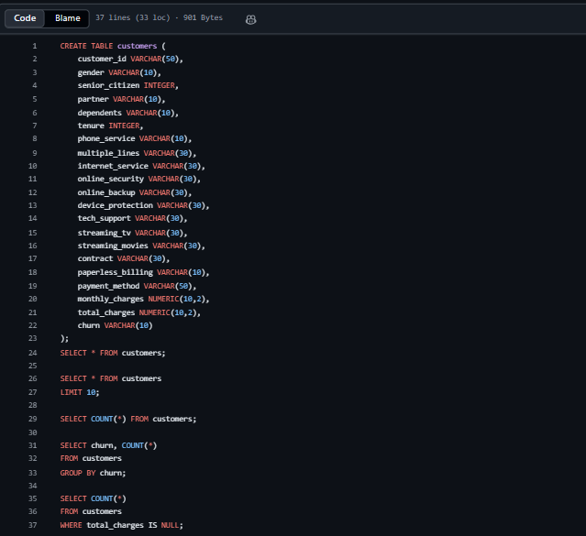

SCREENSHOT OF PYTHON CODE
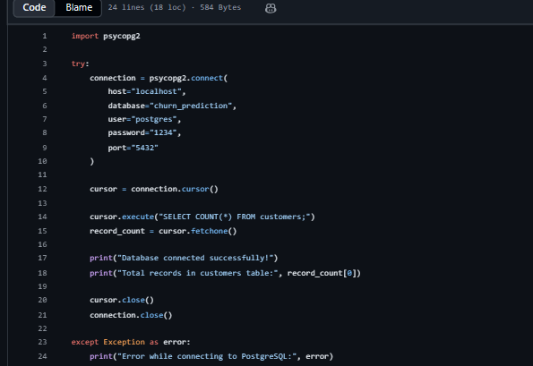
This code connects Python to the PostgreSQL churn_prediction database using the psycopg2 library and checks whether the connection is successful. It then executes an SQL query to count and display the total number of records present in the customers table.

- DATA ANALYSIS
The purpose of the dataset analysis is to study the customer churn dataset before designing the machine learning algorithm. During this analysis, the dataset is loaded using the programming languages Python and Pandas. This involves determining the information about customers that is available, finding out if there are any missing values, and identifying columns with numbers or text.
Tasks Performed for Sample Dataset Analysis
1. Loading the Dataset
The dataset was loaded into Python using the Pandas library with the read_csv() function. This step checks whether the dataset file is accessible and loaded correctly without any errors.
2. Displaying the First 5 Rows
The df.head() function was used to display the first five rows of the dataset. This helps in verifying that the data has been loaded properly and allows understanding of the column structure and sample values.

SCREENSHOT
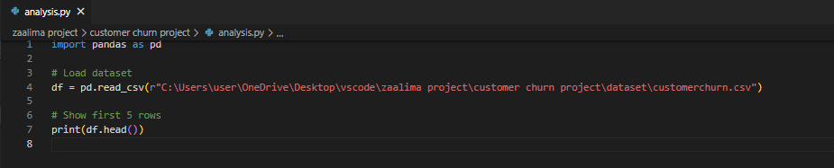
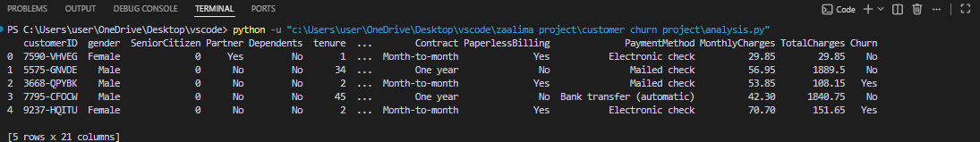

NOTE-> These tasks were performed as a sample analysis to verify whether the dataset was loaded successfully and functioning properly in the Python environment. The checks helped confirm that the dataset could be accessed, analyzed, and used correctly for further preprocessing and machine learning tasks.

